SKILL AND JOB RECOMMENDER PNT2022TMID50980

DEVELOPING A CHATBOT

|  |  |
| --- | --- |
| Date | 9 November 2022 |
| Team ID | PNT2022TMID50980 |
| Project Name | Skill/Job Recommender Application |

Build the Chatbot

**Step 1:** Login to IBM Cloud

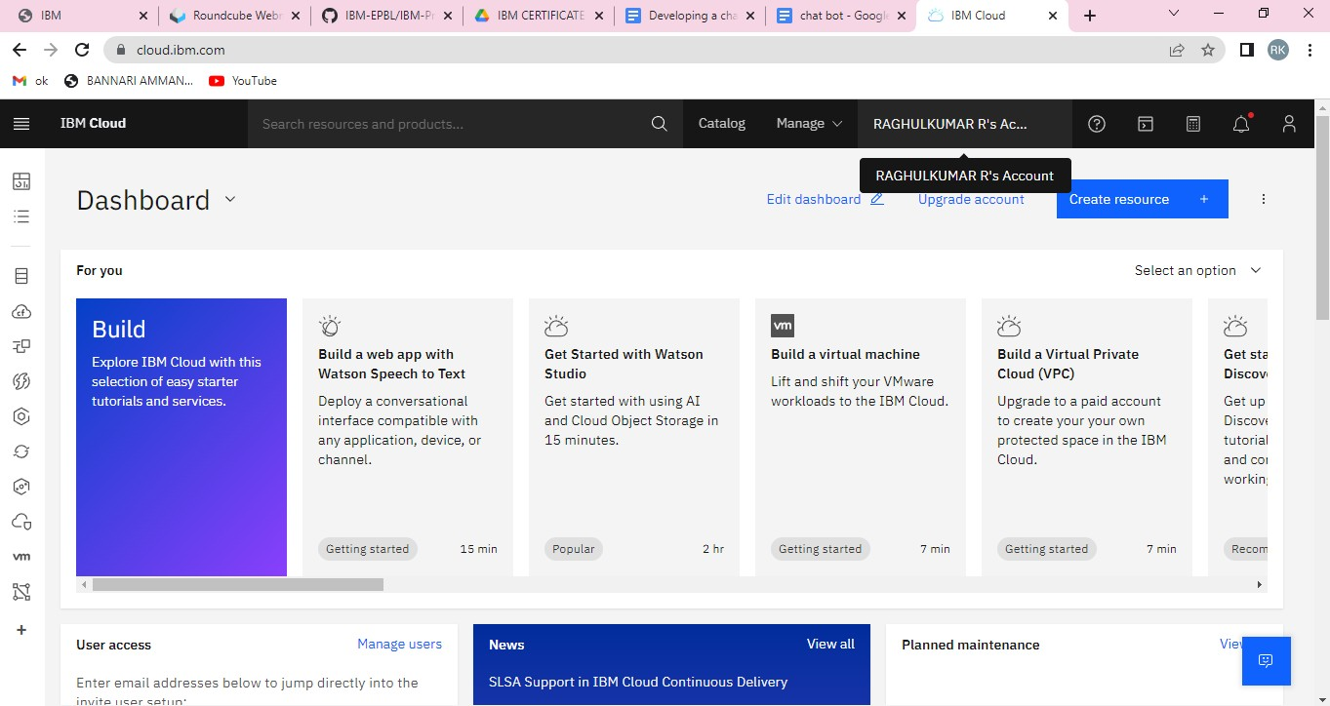

**Step 2**: Search *Watson Assistant*

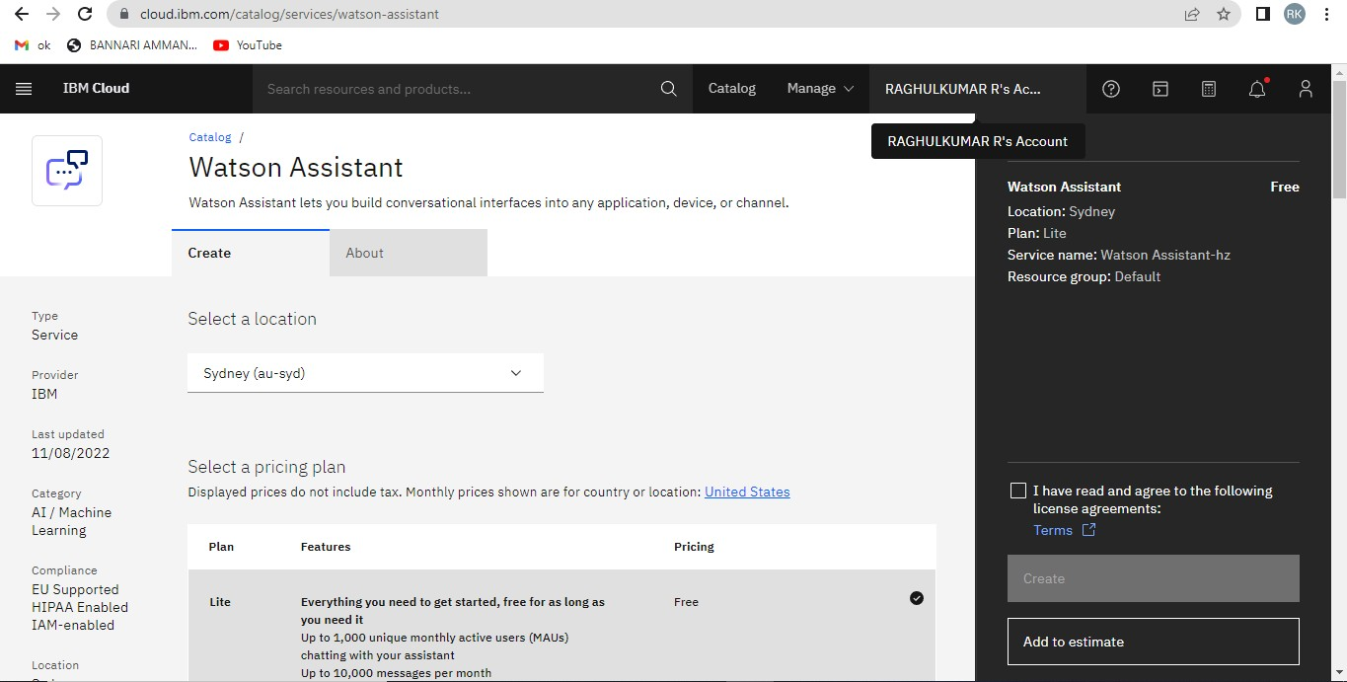

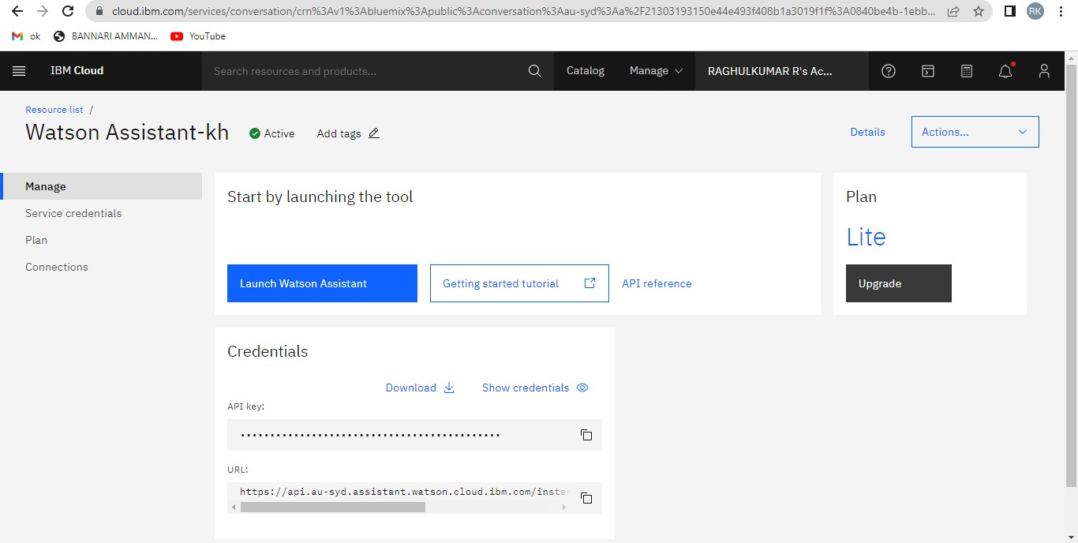

**Step 4:** Then Get Started

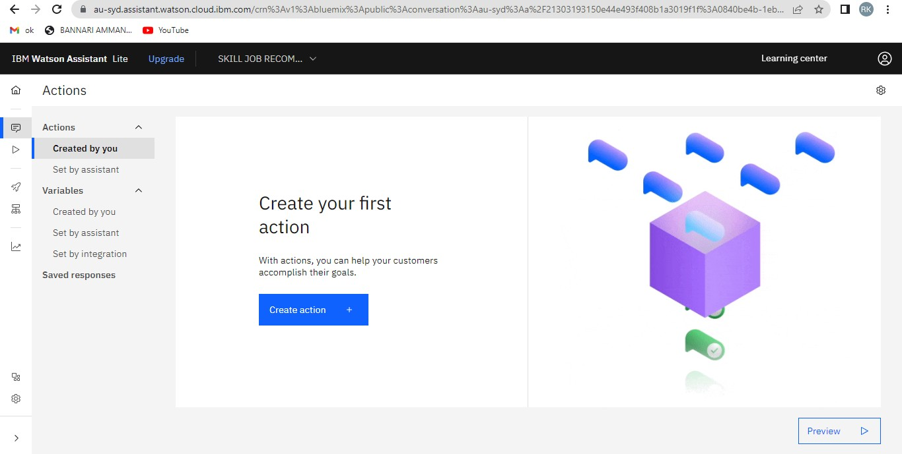

then end Action.

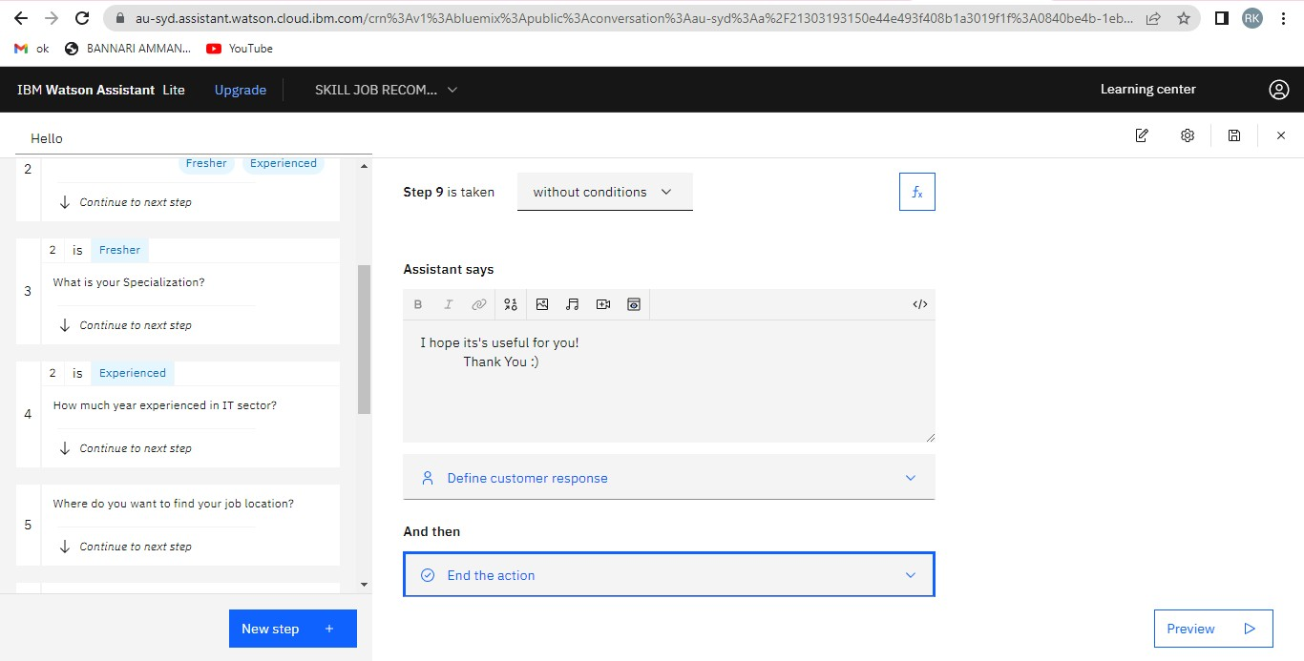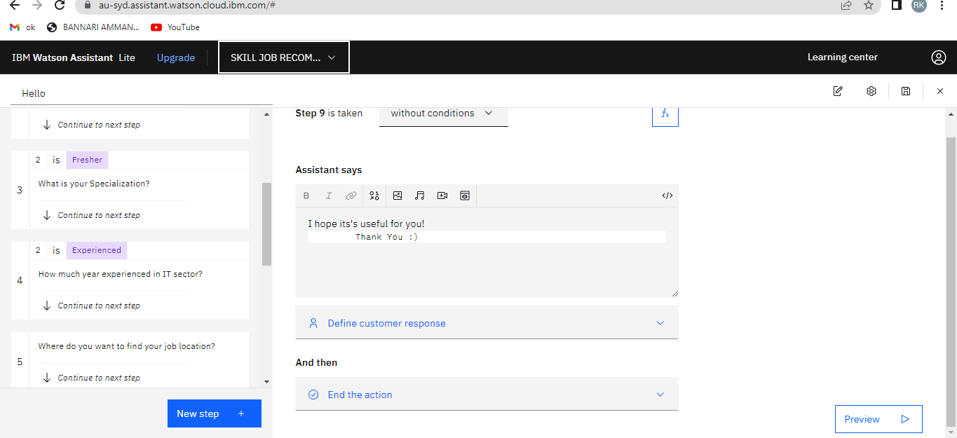

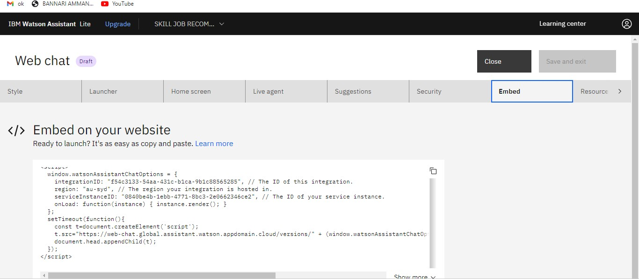

**Step 7**: Create a text file and paste the code and save it .html file

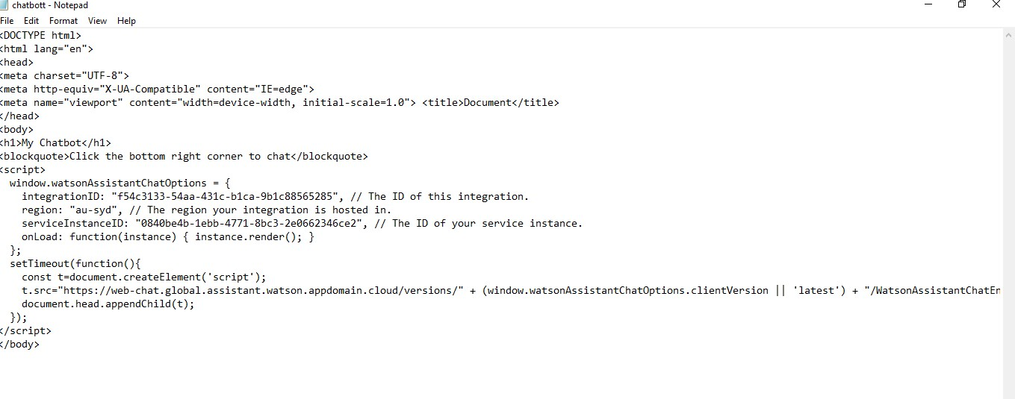

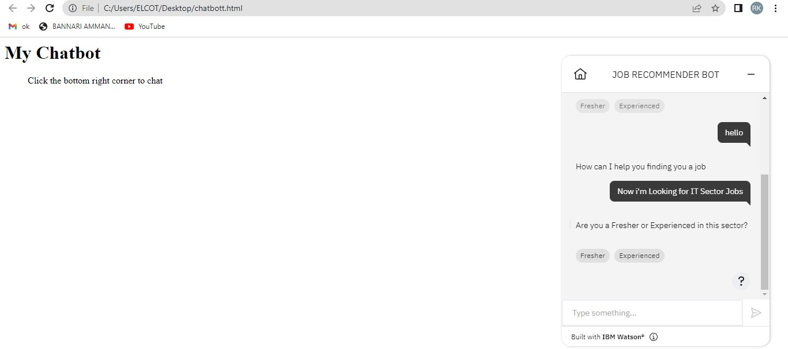

The Chatbot is created and integrated successfully.